**Experiment No. 2.3**

**Name:** Aaryan Aneja **Branch:** BE-CSE **Semester:** 6th

**UID:** 21BCS9186

**Sec./Group:** CC-646_B

**Date:** 19 March 2024

**Subject Name:** Cloud Computing and **Subject Code:** 21CSP-378 Distributed Systems Lab

# **Aim:** Discover a method for initiating a virtual machine using the TryStack (Online Open Stack Demo Version)

* **Objective:** To launch virtual machine using trystack.
* **Procedure:**
  1. **Access Trystack Dashboard:**

# Go to the Trystack website (https://trystack.org/).

* Log in to your account or create one if you don't have an account.

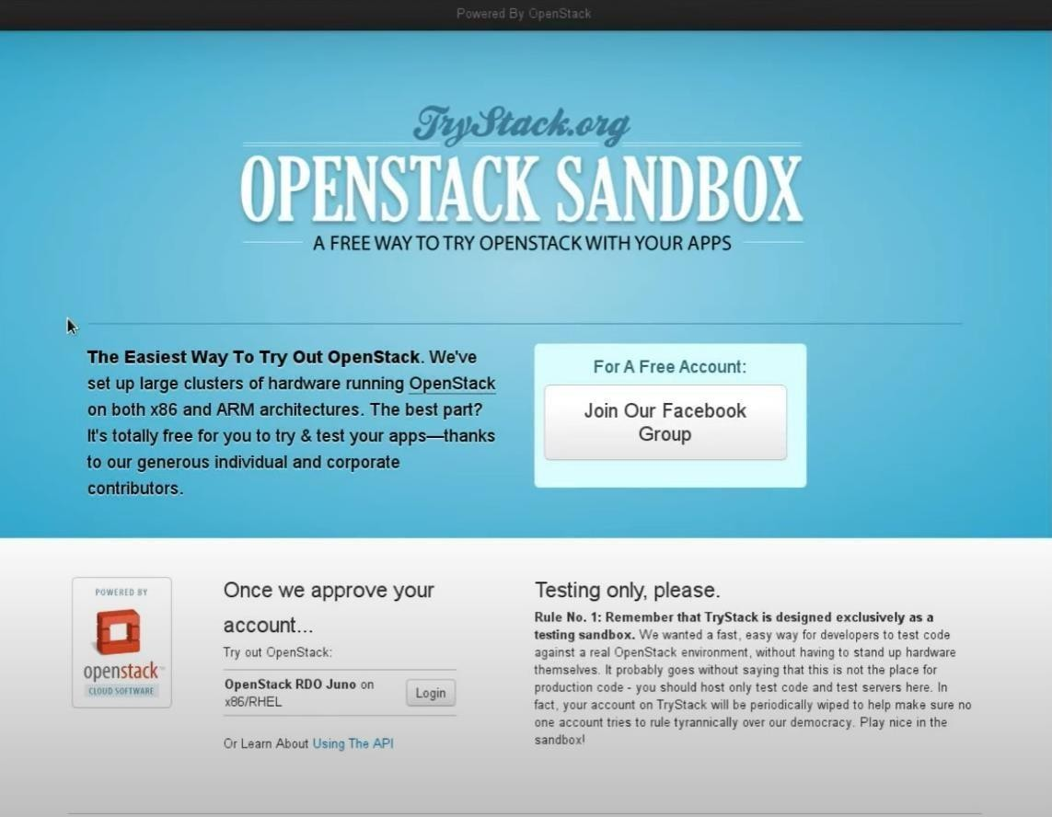

* After you log in to the TryStack, you will see the Compute Dashboard like:

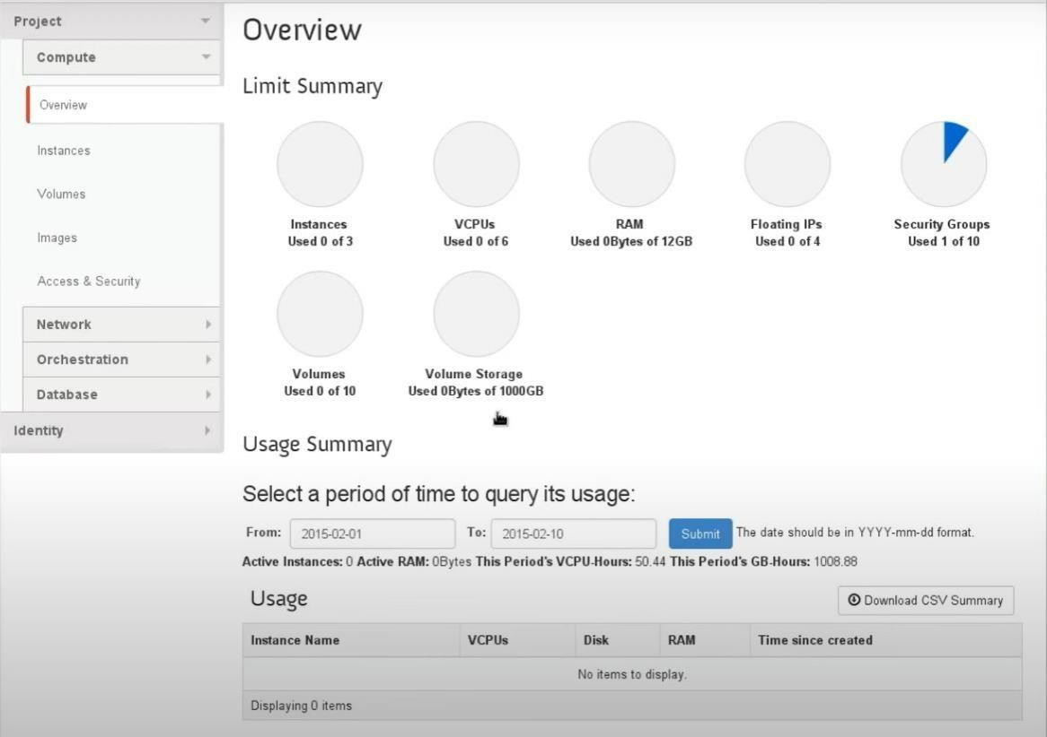

* 1. Create a private local network in Trystack by going to Network > Networks, providing a name (e.g., "internal"), and specifying a CIDR block (e.g., 192.168.1.0/24).

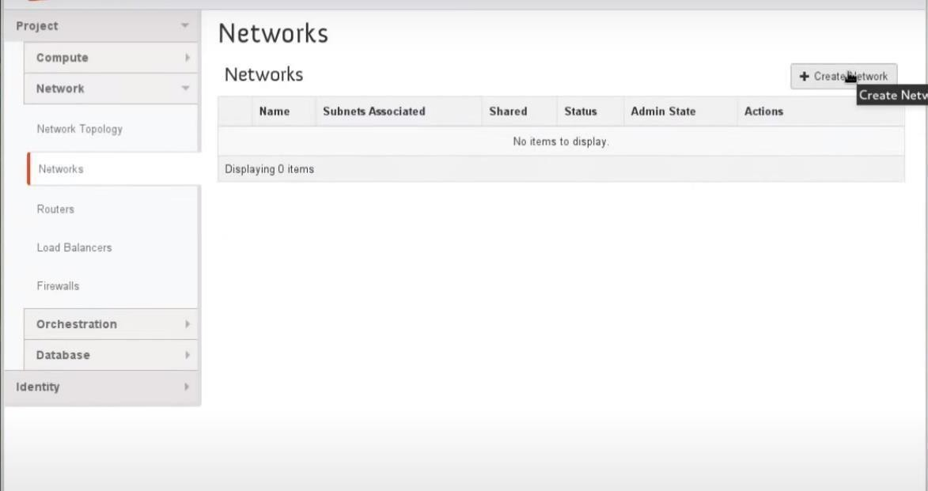

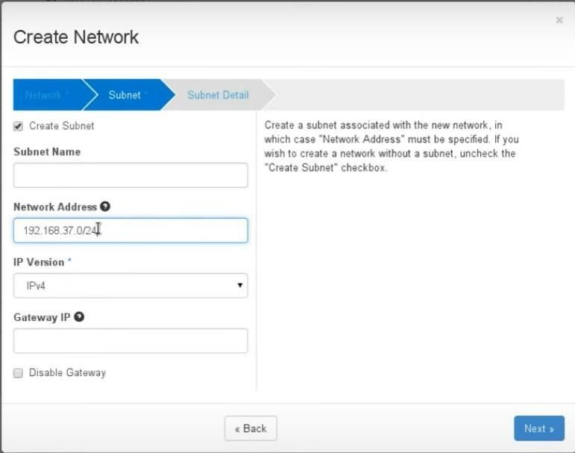

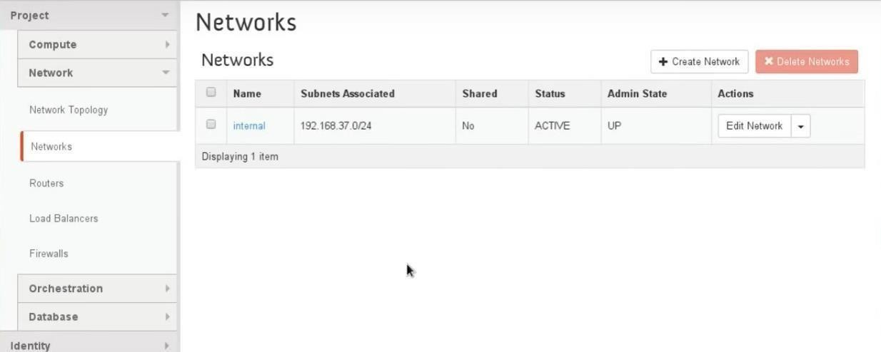

* 1. Launch an instance by going to Compute > Instances, providing details like instance name, flavor, and image. Connect the instance to the created network and set up key pairs and security groups.

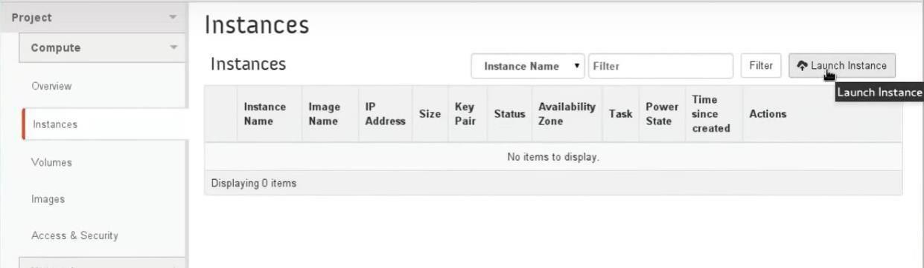

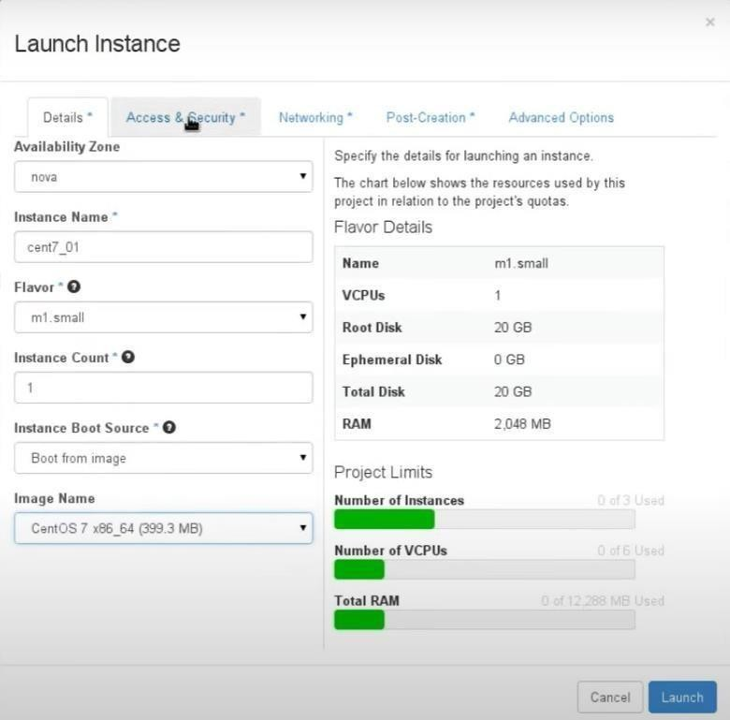

* 1. Create a router in Network > Routers, connect it to the external network, and associate it with the internal network to enable internet access.

Configure a floating IP for your instance in Compute > Instances, allowing public access. Set up security rules in Compute > Access & Security for ICMP, HTTP, and SSH. SSH into your instance using the assigned floating IP.

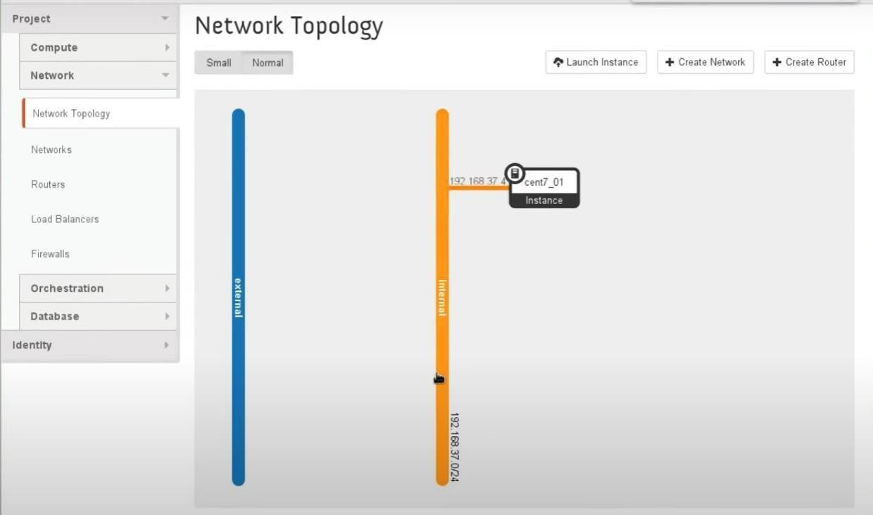

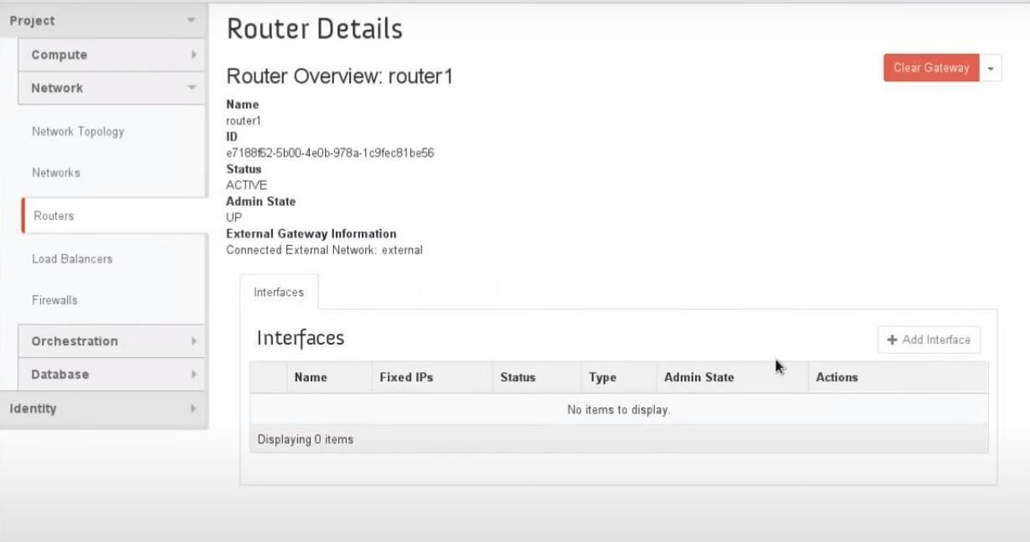

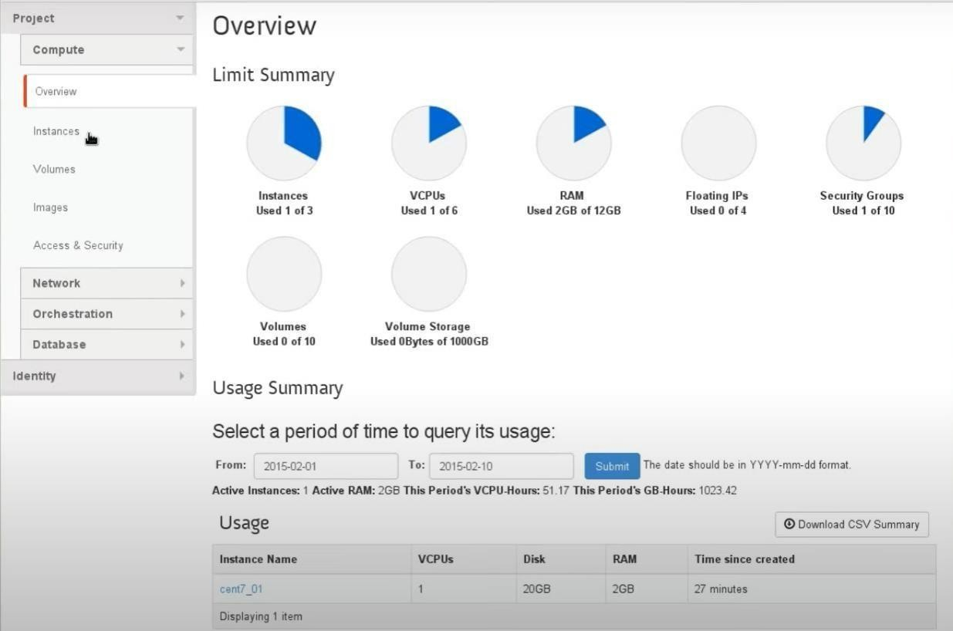

**Learning Outcomes:**

* Gain foundational knowledge of cloud computing through TryStack, launching a virtual machine.
* Develop practical skills in OpenStack by navigating TryStack's interface for VM initiation.
* Enhance problem-solving abilities by troubleshooting common cloud provisioning issues on TryStack.
* Deepen understanding of virtualization concepts via hands-on experience with TryStack's VM deployment.